# **Principle of Database Management Report**



# **PHARMACY MANAGEMENT**

Instructor: Mrs.Loan

Class: Monday morning

Semester II – Academic year: 2019 - 2020

# **INDEX**

|  |  |
| --- | --- |
| **Title** | **Page** |
| Index | 2 |
| Members and Roles | 3 |
| Introduction | 4 |
| Entity Relationship Diagram | 5-7 |
| Relational Database Schema | 7 |
| Database | 8-10 |
| Programming | 10-12 |
| Conclusion | 12 |

1. **MEMBERS AND ROLES**

|  |  |  |
| --- | --- | --- |
| Trần Đức Hải Phong | ITITIU16048 | * Writing initial proposal report. * Creating database. * Enhance ERD. * Introduction and Database part of report. |
| Diệp Phương Quỳnh | ITITIU17041 | * Drawing first ERD. * Programming to connect database with java. * Write final report. |
| Nguyễn Hoàng Phiên | ITITIU14078 | * Convert ERD to database schema * Programming to connect database with java. * Conclusion part in report. * PowerPoint presentation. |

1. **INTRODUCTION**

Replace current paper data into database store in computer/server (for big company)

1. **For workflow:**  works via DBMS. Using DBMS (SQL, MySQL) for storing data instead of notes. Work as a website.
2. **Identify DBM:** our system work as DB-Centered information sharing for doctors, medical staff, patients. User con log-in to website to find, buy medicines they want.
3. **Data store in DB:**

Related tables will store patient medical’s history. There will be 2 types of information:

+User information (address, name, phone number, etc)

+Medicine information (suppliers, drug name, etc)

1. **Drug updates:**

Admin will update for more medicine if store buy new one.

1. **ENTITY RELATIONSHIP DIAGRAM**

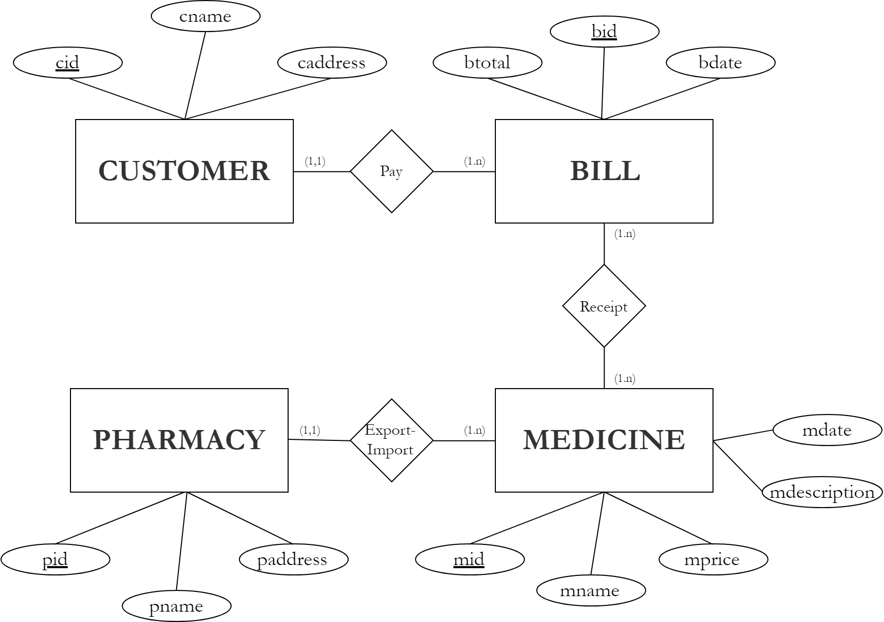

There are four entities in this system: CUSTOMER, BILL, PHARMACY, MEDICINE and three relationships: Pay, Receipt, Export-Import.

Information:

**CUSTOMER table**

|  |  |
| --- | --- |
| **Column** | **Description** |
| cid | In Pharmacy Management database, this integer column is defined as autoincremented. For each row inserted in this table, the database automatically increments the *cid* value to ensure that each row has a unique *cid*. This column represents the table’s primary key. |
| cname | Customer’s name (a string) |
| caddress | Customer’s address (a string) |

**PHARMACY table**

|  |  |
| --- | --- |
| **Column** | **Description** |
| pid | This autoincremented integer is the table’s primary key. |
| pname | Pharmacy’s name (a string) |
| paddress | Pharmacy’s address (a string) |

**MEDICINE table**

|  |  |
| --- | --- |
| **Column** | **Description** |
| mid | This autoincremented integer is the table’s primary key. |
| mname | Medicine’s name (a string) |
| mdate | Production date of medicine (date) |
| mdescription | Medicine’s description (a string) |
| mprice | Medicine’s price (a real number) |
| pid | The pharmacy’s ID number, a foreign key to PHARMACY table |

**BILL table**

|  |  |
| --- | --- |
| **Column** | **Description** |
| bid | This autoincremented integer is the table’s primary key. |
| bdate | Date prints bill (date) |
| btotal | Total of bill (a real number) |
| cid | The customer’s ID number, a foreign key to the CUSTOMER table |

1. **RELATIONAL DATABASE SCHEMA**

**Pharmacy-schema**=(**pid**,pname,paddress)

**Medicine-schema**=(**mid**,mname,mdescription,mdate,mprice,*pid*)

* From Mecicine-schema.pid to Pharmacy-schema.pid

**Bill-schema**= (**bid**,bdate,btotal, *cid*)

* From Bill-schema.cid to Customer-schema.cid

**Customer-schema**=(**cid**,cname,caddress)

**Receipt-schema**=(***mid,bid***,rid)

* From Receipt-schema.*mid* to Medicine-schema.*mid*
* From Receipt-schema.*bid* to Bill-schema.*bid*

1. **DATABASE**

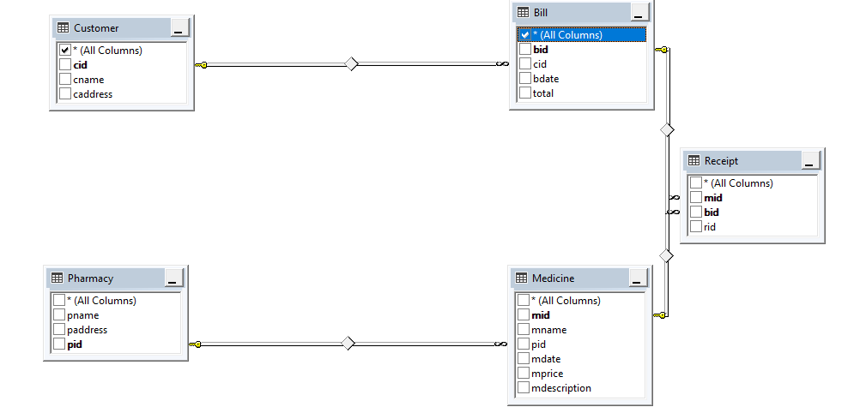

Bill

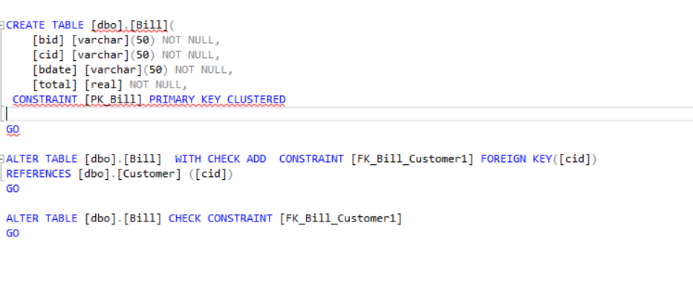

Customer

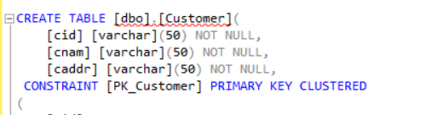

Medicine

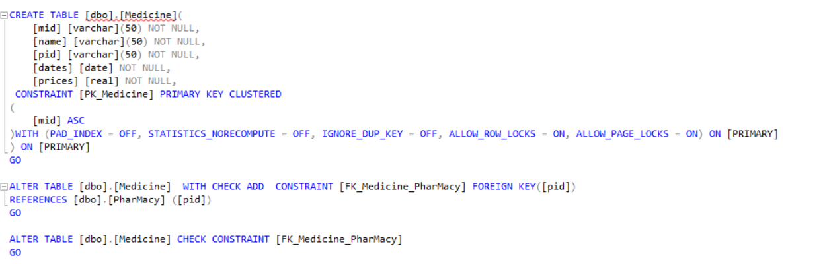

Pharmacy

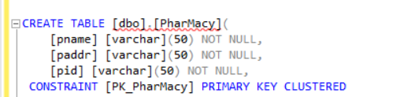

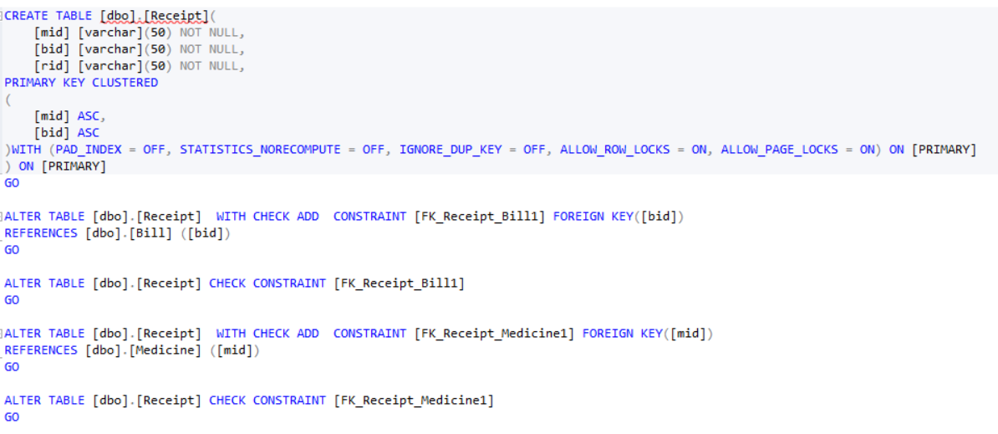Receipt

1. **PROGRAMMING**
2. DisplayCustomer

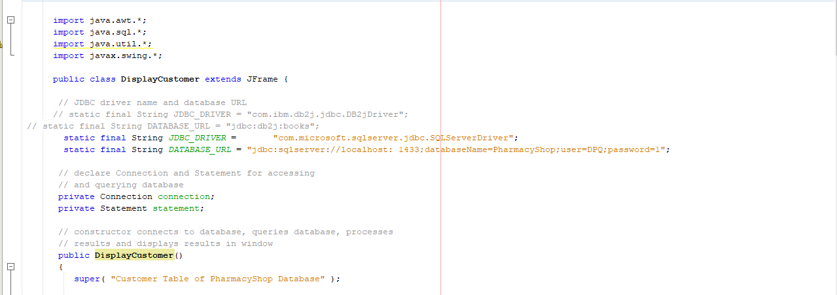

Result

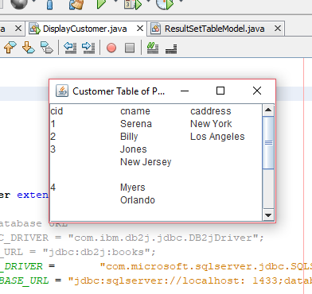

1. DisplayQueryResult

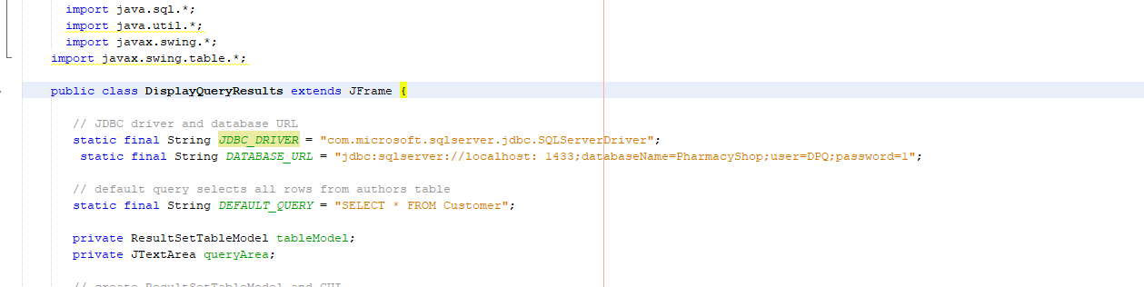

Result

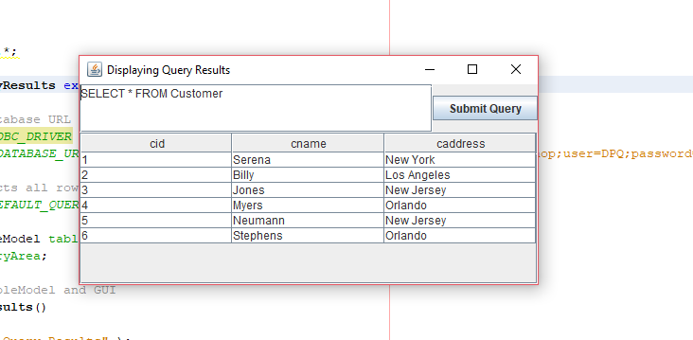

1. **CONCLUSION**

The Principles of Database Management course purpose is to provide basic overview of how Database works in real life. While maintain its abstract properties, Database can also be somewhat realistic.

To successfully create a fully functional database, every single step must be followed strictly from the analysing step to ERD drawing, convert them into schema and finally create the database itself, not to mention all the query and technique required in the final step.

Although database can be confusing, we cannot deny the effectiveness of it and how easy things can be managed when a good database system is implemented.

Nowadays database has become critical in almost every area in the world. Data is information, information means potential target. For those reasons, Database management is more than important.

A system like Pharmacy Management can greatly help in many ways. Reducing data redundancy, data integrity and consistency are the main benefits. It helps pharmacists to manage all the products, store customer information and also their records while keep their information save.